September 9, 2019

Dear Potential Sponsor,

Work is underway on this year’s Monroe 2–Orleans Educational Foundation Celebration. Our celebration raises money to support efforts benefitting students from Brockport, Churchville-Chili, Gates Chili, Greece, Hilton, Holley, Kendall, Spencerport and Wheatland-Chili School Districts by reaching students from non-traditional programs (such as career and technical education and special education) who wish to continue their education after high school.

The Make All the Difference Scholarship Program is the sole benefactor of the generous donations raised at this annual event. Your contribution helps to support our local high school students by opening doors for those who often go unrecognized.

Thanks to our generous partners, the Foundation was able to award $100,000 in scholarships to local students this past June. For your convenience, we have enclosed a Foundation brochure and information on sponsorship and giving levels.

Your donation is tax deductible and will be prominently recognized in our Celebration program, in signage at the event and in the Monroe 2–Orleans BOCES newsletter, Together, (circulation 1,100). Your level of sponsorship will also entitle you to a number of reservations at the event.

Please contact Jo Anne Antonacci at: jantonac@monroe2boces.org or (585) 352-2410 to confirm your giving level and make arrangements for your program ad. On behalf of the Educational Foundation board and the students we represent, your support is deeply appreciated.

Thank you for your consideration.

Sincerely,

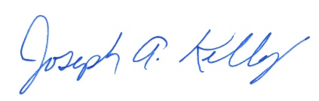
Joseph Kelly
President

SAVE THE DATE: This year’s Celebration is Saturday, November 2, 2019 at 6:00 p.m. at Ridgemont Country Club.

