Parent Access To The SchoolTool Parent Portal
The Parent Portal is a component of the SchoolTool program, and allows a parent or legal guardian secure access to their student's class schedule, report cards, IEP and AIS progress reports and Work Based Learning evaluations

New Users:
You must register to use the Parent Portal by completing the appropriate Parent Portal registration form. Due to the nature of the information available through the Parent Portal, for security reasons registrations will not be accepted if a parent or guardian is NOT listed as a contact in the SchoolTool Database. BOCES 2 will need to confirm emergency contact status through the student’s home school. Parent Portal Registration Forms are available through the Exceptional Children Website. Once your registration information has been verified, you will receive an Email confirmation of an account and password. You can access the Parent Portal through the following web address:
www.monroe2boces.org/ecportal

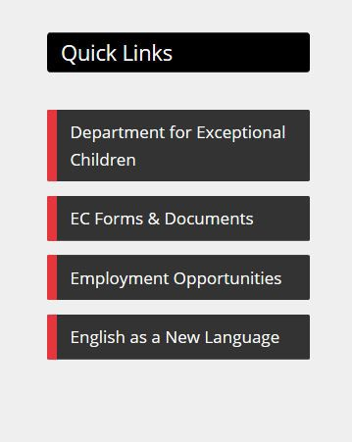

Look for the SchoolTool Login in the Quick Links section located
on the Exceptional Children department website.

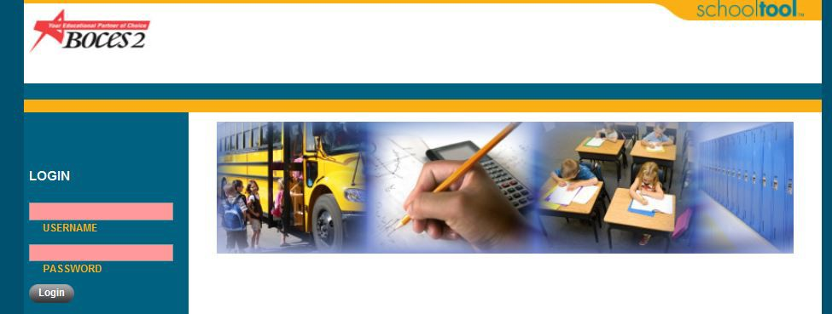
Enter your Username and Password:

Your Username is your Email address that is on record with BOCES.

You have 5 password attempts before you will be locked out. See page 3 for instructions on unlocking your account.

Once logged in, you will be greeted with your My Home page, which will list your enrolled students.
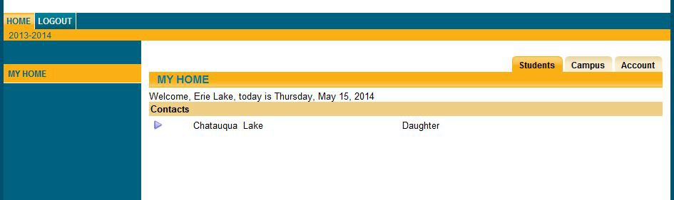
Click on the triangle
to open your student's school information.

The green arrow allows you to navigate back to the My Home page to view other students you have enrolled.
DO NOT USE
THE BACK BUTTON on your Internet browser
The Grades Tab:
Allows you to view and print your student's report card by school year, marking period, and quarter.

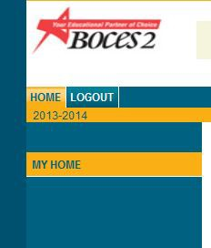
For security reasons, always remember to Logout.

If you are having problems with access to your
Parent Portal Account, or have a change in Email address, please e-mail the below address:

ecparentportal@monroe2boces.org

Please include your name, home address, Email address, and student’s names in all correspondence.

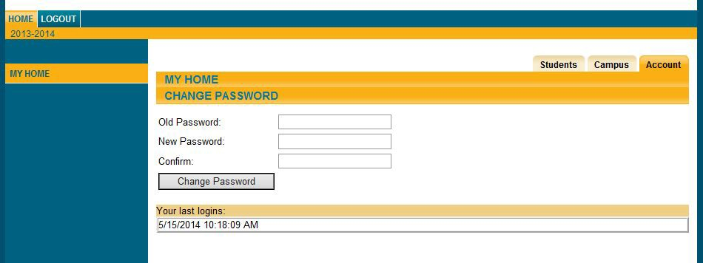
Click on the Account Tab, and enter your assigned password in the Old Password window. Type the desired password in the New Password window, and again in the Confirm window.

Click the Change Password button to finalize the change.

** PLEASE NOTE: Keep your password in a safe place, as we do not keep a list of passwords. If you lose your password, you will need to go through the Forgot Password process described below to reset it. **

